SAP Concur Travel QuickStart Guide


SAP Concur Technologies Version 1.7

August 27, 2018

Table of Contents

Table of Contents 3
Updating Your Travel Profile 4
Travel Arranger 4
Access 4
Booking a Flight 6
Step 1: Start the Search 6
Step 2: Select a flight 8
Step 3: Select a rental car 10
Step 4: Select a hotel 10
Step 5: Review the Travel Details page (itinerary) 10
Step 6: Review the booking information 13
Step 7: Purchase the ticket 14
Booking a Car 14
Step 1: Search for your Car 14
Step 2: Filter the results 14
Step 3: Sort the results 15
Step 4: Review the results 16
Step 5: Select the rental car 16
Booking a Hotel 17
Step 1: Search for your the Hotel 17
Step 2: Change and filter your search 17
Step 3: Review the hotel map 17
Step 4: Sort the search results (as needed) 18
Step 5: Review the results 19
Step 6: Select the hotel room 19

Updating Your Travel Profile
Before you use SAP Concur's travel application for the first time, update your Travel profile. Even if you make no changes, you must save your profile before you can book a trip in Travel.
Notes:
- Some companies have custom fields on this page. Check with your agency or Travel administrator if you need information on custom profile fields.
- Depending on your company's configuration, some of these options may not be available to you. Check with your SAP Concur administrator.
- Depending on your company's configuration, this area in Profile may appear even if your company does not use SAP Concur Travel.
Use the Travel profile options to set or change your personal Travel preferences and settings. They include:
- Assistant or travel arranger
- Credit card
- Email options
- E-Receipts
- Language
- Password
- Personal preferences (name, address, emergency contact, credit card)
- Regional preferences (number format, date format, language)
- Register for SAP Concur for Mobile
- Travel preferences (air, hotel, car rental, rail preferences)
- Travel vacation reassignment
and
- Other preferences and settings (default home page, calendar, emails, accessibility mode)

Travel Arranger
If you are a travel arranger and you want to change the profile of one of your users:
- Click Profile.
- In the Administer for another user field, type the first few letters of the user's name.
- Select the appropriate user from the search results.
- Click Apply.

Access
To access your profile information:
- Click Profile > Profile Settings.
The Profile Options page appears.
- Select the appropriate option under Profile Options, or from the links on the left side of the page.
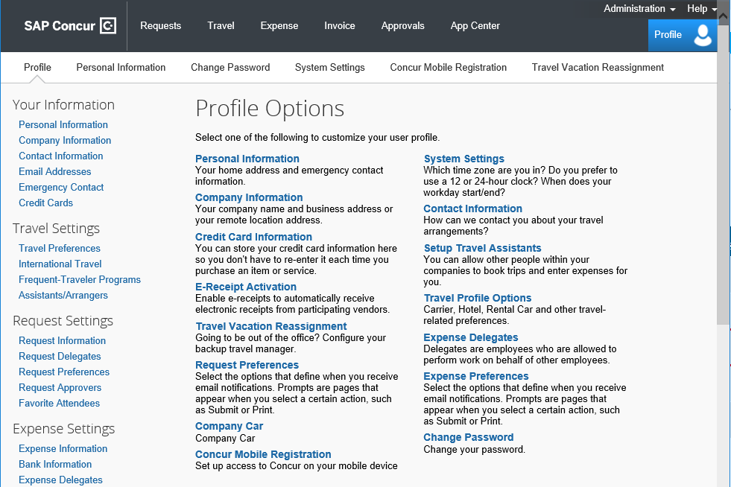

Booking a Flight
From the SAP Concur home page, use the Flight  tab to book a flight by itself or with car rental and/or hotel reservations. To book car and hotel reservations without a flight, use the Hotel  and Car  Search tabs, respectively.
Note: If your company is configured to use rail, then the Flight tab may show Air / Rail .
You can access the Flight tab (or Air / Rail ) by doing the following:
- On the SAP Concur home page, on the menu, click Travel.
- On the SAP Concur home page, on the menu, click the SAP Concur logo.
The Flight tab (or Air / Rail tab) is on the left side of the page.
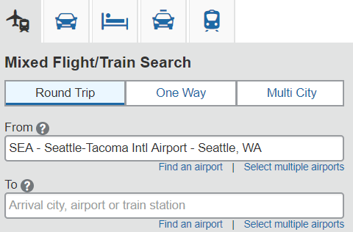

Step 1: Start the Search
- Depending on your company's configuration, you might be able to select a rule class. If so, select the appropriate rule class.
- Select one of the following types of flight options:
- Round Trip
- One Way
- Multi City
- In the Departure City and Arrival City fields, enter the cities for your travel. When you enter a city, airport name, or airport code, SAP Concur will automatically search for a match.
Note: Use the Find an airport and Select multiple airports links as needed.
- Click in the Departure and Return date fields, and then select the appropriate dates from the calendar. Use the remaining fields in this section to define the appropriate time range.
- Click the 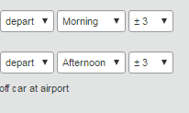 arrow to the right of the time window to see a graphical display of nonstop flights available for the routing and date you have selected. This allows you to adjust your search criteria, if necessary, to see/reserve nonstop flights.
Notes:
- The graphical display is based on flight schedule data. It will not show any rail options, nor can it take refundability or class of service preferences into account.
- Each green bar represents 30 minutes of time. Place your mouse pointer over a green bar to see all the flights available for that time slot.
- If you change locations or dates, click refresh graph for more data.
- If you need a car, click the Pick-up / Drop-off car at airport check box.
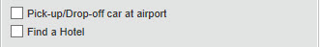
- Depending on your company's configuration, you might be able to automatically reserve a car, allowing you to bypass viewing the car search results. When you select this option, additional fields appear. Select a vendor and car type; the car is automatically added to your reservation.
- If you need an off-airport car or have other special requests, you can skip this step and add a car later from your itinerary.
- If you need a hotel, click the Find a Hotel check box.
Additional fields appear.
- Choose to search near an Airport, Address, Company Location, or Reference Point / Zip Code, and then enter the appropriate information in the available fields.
- If you are staying at more than one hotel during your trip or do not need a hotel for the entire length of your stay, you can skip this step and add a hotel later from your itinerary.
Note: Before booking, canceling, or changing your hotel reservation, verify the hotel's cancellation policy. Hotel cancellation policies have recently become much stricter. Fees will likely apply.
- Depending on your company's configuration, you might be able to specify an airline. If so, the Specify airline check box appears.
Note: You can only search one vendor at a time, and this will override the preferred airline searches normally done for all the frequent flyer number carriers.
If you click the Specify airline check box, a list of carriers appears that are color coded:
- The first (yellow) will be their frequent flyer carriers.
- The second (gray/khaki) are the most requested airlines.
- The remaining airlines are in alphabetical order.
- Depending on your company's configuration, you might be able to book for a companion. If so, select from the Number of adults list.
Note: If a companion is selected, the payment screen provides the option to use the credit card from the companion's profile.
- Depending on your company's configuration, you might be able to select the appropriate class of service.
- For Search flights by, select either Price or Schedule. (Depending on your company's configuration, you may not have these options, or you may have an additional option: Multi-Fare.)
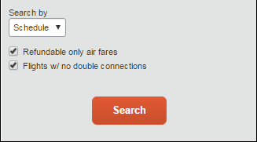
- To search only for refundable flights, click the Refundable only air fares check box.
- If necessary, uncheck the Flight w/ no double connections check box.
- Click Search.
The flight search results appear.

Step 2: Select a flight
On the Flight Search results page:
- If you selected to Search by Price on the previous page, then the Shop by Fares tab is initially active.
- If you selected to Search by Schedule on the previous page, then the Depart tab is initially active.
In the following example, Search by Price was selected on the previous page.
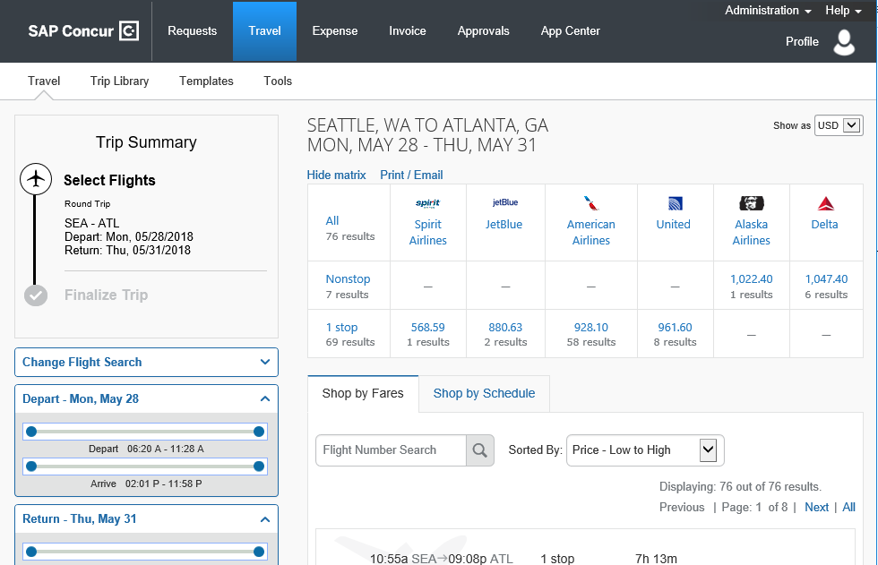
- On the Shop by Fares tab, to view additional details for the flights, click the Show all details dropdown arrow.
- To select a flight, click the fare button.
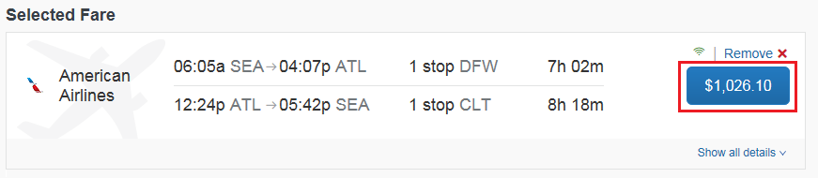
- On the Review and Reserve Flight page, review the flight details for your trip.
- On the Review and Reserve Flight page, you can do the following:
- Review your flight details
- Enter your traveler information
- Select your frequent flyer programs
- Select your seat assignment
- Review the price summary
- Select your method of payment
Note: Depending on your airfare provider, you can click the View seats map link to select your seat on the flight. Select the appropriate Available seat from the Seat Map.
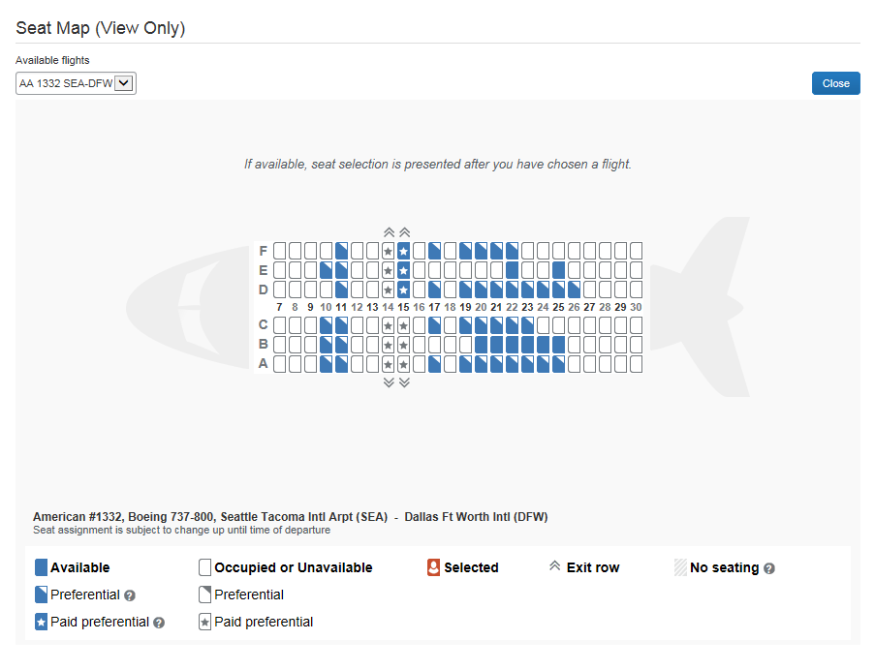
- Click Reserve Flight and Continue.

Step 3: Select a rental car
If you requested a car on the Flight tab (or Air / Rail) Search, the rental car search results appear. For information about booking a rental car, see Booking a Car in this document.

Step 4: Select a hotel
If you requested a hotel on the Flight tab (or Air / Rail) Search, the hotel search results appear. For information about booking a hotel, see Booking a Hotel in this document.

Step 5: Review the Travel Details page (itinerary)
- On the Travel Details page, review and change your itinerary, if necessary.
- In the Trip Overview section:
- Review the information for accuracy.
- In the I want to section, print or email your itinerary as appropriate.
- In the Add to your Itinerary section, add a car, hotel, Wi-Fi, etc., as needed.
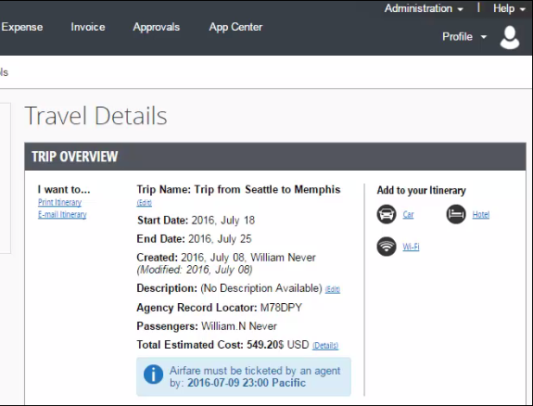

- In the Flight section:
- Verify the information for accuracy.
- Click Select Seat or Change Seat to select or change your seat option (depending on the airline).
- Your company might allow you to change or cancel your flight from the itinerary page. If so, click Change or Cancel, and then follow the prompts to change your outbound or return flight.
Travelers given the option to change a flight will be able to select a different date or time for the trip but must stay on the same airline.
Note: Changing a flight can result in fare changes. If this option is available to you, please make sure to check with your travel agency on fare differences.
- Click Cancel all Air, as needed.
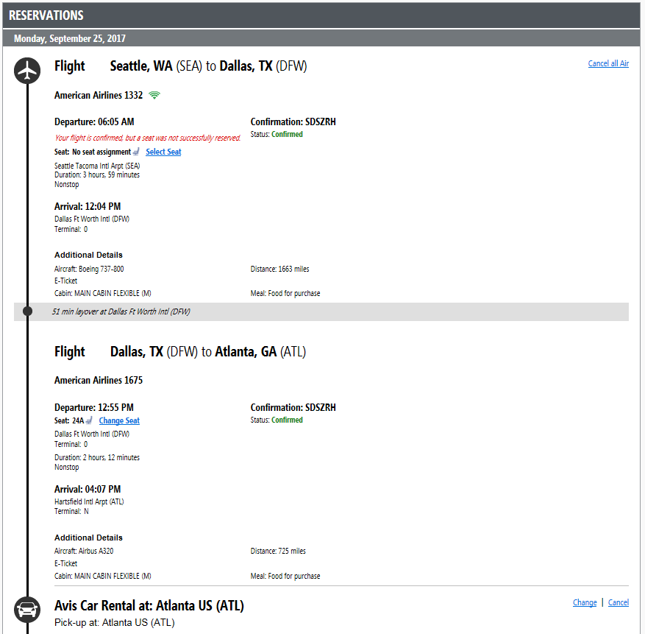
- Review the remaining sections and make the appropriate changes.
- Review the Total Estimated Cost section.
- Click Next.
- The Trip Booking Information page appears.
- The Trip Booking Information page appears.

Step 6: Review the booking information
Use the Trip Booking Information page to enter additional information about your trip.
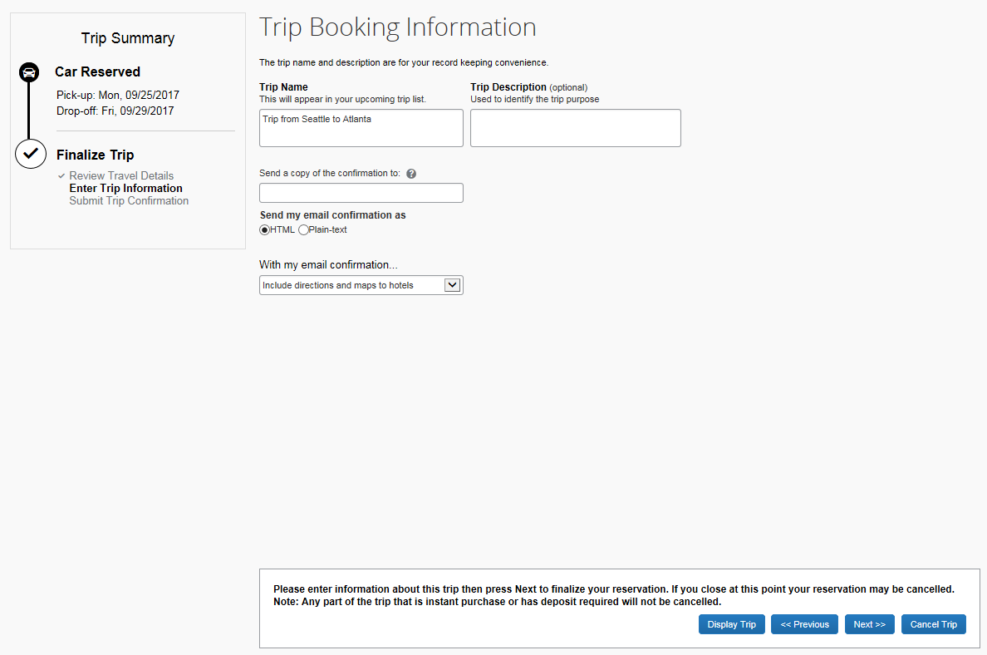
- Enter or modify your Trip Name.
This is how the trip will appear on your itinerary and in the automated email from SAP Concur.
- Enter a Trip Description (optional).
- Indicate if there is anyone else who should receive the initial confirmation email. Enter as many recipients as needed, separated by commas.
If you book the trip, you will automatically receive the email. If you book the trip as an arranger, you will also receive the email.
- Choose your preferred email format, either plain text or HTML.
Note that some companies do not offer travelers this option and always send plain-text email.
- Depending on your company’s configuration, you might be able to choose whether you would like to receive directions or maps to the hotel.
This information will be part of the initial email from SAP Concur.
- Depending on your company’s configuration, your company might require billing information. If so, make sure to complete this information if requested.
Note: Your company might offer its travelers the option to hold a trip. Travel will always display the length of time this trip can be held on this page. Pay close attention to the date and time displayed; if the trip is not submitted, approved, and ticketed by the date and time displayed, in most cases it will be automatically cancelled.
- Click Next.
SAP Concur displays your itinerary on the Trip Confirmation page. This itinerary will include any messages about ticketing policies.
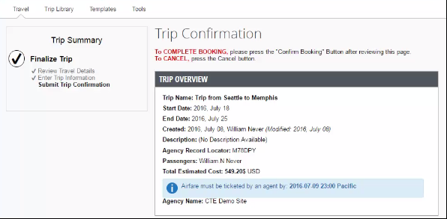

Step 7: Purchase the ticket
- Click Confirm Booking to send your request to your travel agent and to your manager for approval.
Depending on your company’s configuration, the Pre-populating Your Expense Report page appears. You can add transportation expenses for your trip to and from the airport.
- Click Finish.
The Finished! screen shows your confirmation number and information to contact the travel agent.
- Click Return to Travel Center.
Booking a Car

Step 1: Search for your Car
If you require a car but not airfare, from the SAP Concur home page, request the car using the Car tab instead of the Flight (or Air / Rail ) tab.
- Enter your pick-up and drop-off dates and times.
- In the Pick-up car at section, select either:
- Airport Terminal, and then type the city or the Airport code.
- Off-Airport, and then enter (or search for) the location.
Depending on your company's configuration, you may be able to have a car delivered to or picked up from your company location.
- Select the Return car to another location check box, as needed.
If you want to return the car to another location, additional fields will appear. Select either Airport Terminal or Off-Airport, and then enter the appropriate location.
- To see additional search preferences, click More Search Options.
- Select the Car Type.
Tip: Hold the Ctrl key to select more than one type.
- Select all your preferences, and then click Search.
The rental car search results appear.

Step 2: Filter the results
There are two sets of filters: The matrix at the top of the page, and the Change Car Search area on the left side of the page.
To filter your results using the Change Car Search area
- On the left side of the page, use the show and hide arrows.
- Select the Use my default credit card check box, if needed.
This is the credit card that you set up as your default in your profile. Uncheck the check box if this is not the card you want to use.
- In the Change Car Search area:
- Change your pick-up and drop-off dates and times, and your pick-up and drop-off locations.
- Click More Search Options to select additional options such as a car type, and vendors.
- Click Search.
The new search results display.
To filter your results using the Matrix at the top of the page
- Use the grid to filter the results.
- Your company might display only its preferred vendors in the left column.
- The shaded column, if any, displays the type of car defined in your company's travel policy.
- To see a particular size of car, click the cell with the car size. The search results below will reflect that choice.
- To see cars for a particular vendor, click the cell for that vendor. The search results below will reflect that choice.
- To see cars of a particular size and a particular vendor, click the appropriate cell. The search results below will reflect that choice.

Step 3: Sort the results
If you want to sort your results, click the Sorted by dropdown arrow, and then select the appropriate option.

Step 4: Review the results
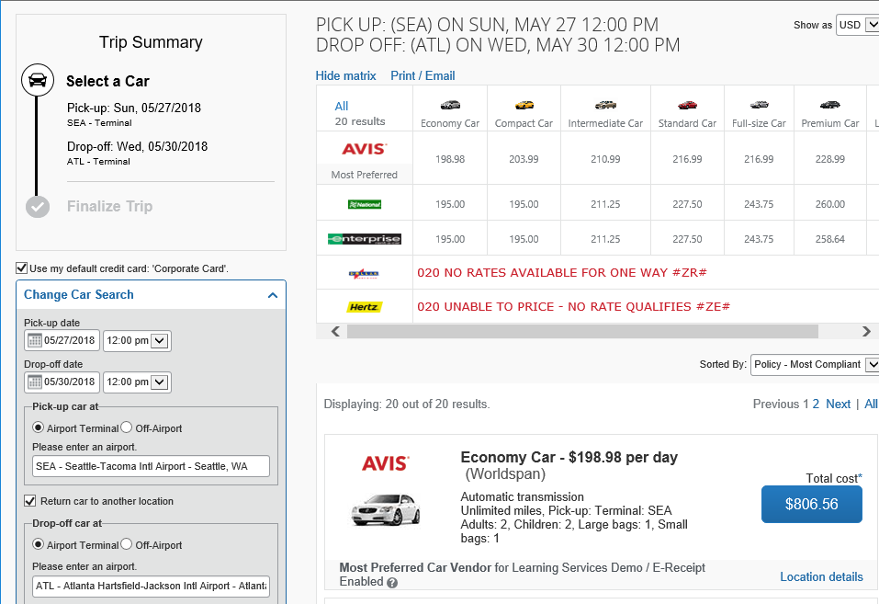
- Review the price and options.
- Click the picture of the car (if available) to see a larger picture as well as passenger and luggage capacity.
- Click Location details for more information about the available options.

Step 5: Select the rental car
- Click the Total cost button.
Note that the color of the Total cost button reflects policy compliance.
The Review and Reserve Car page appears.
- Review the details for accuracy.
- Select a rental car program, as needed.
- Select a method of payment, if necessary.
- Click Reserve Car and Continue.
If you requested the car using the Flight (or Air / Rail ) tab, and you elected to reserve a hotel room, Travel will display those search result pages.

Booking a Hotel

Step 1: Search for your the Hotel
- If you require a hotel but not airfare, from the SAP Concur home page, click the Hotel tab.
- Enter the Check-in and Check-out Dates (or click in the fields to use the calendar).
- Enter the search radius.
SAP Concur will always show company preferred hotels within a larger radius, usually 30 miles or kilometers.
- Choose to search near an Airport, Address, Company Location, or Reference point / Zip Code, and then enter the appropriate information in the available fields.
- If you will be using more than one hotel on your trip, select the Add Another Hotel check box.
Additional fields will appear. The Check-in Date field for the second hotel is automatically populated with the check-out date of the first hotel. Change the date as necessary.
- Click Search.
The hotel search results appear.

Step 2: Change and filter your search
- In the Change search area:
- Change your check-in and check-out dates, and your hotel location.
- Click Search.
Travel displays the new results.
- Use the slider in the Price area to narrow your search.
- In the Hotel chain area, select the appropriate hotels.
- In the Hotel Amenities area, select the appropriate options.

Step 3: Review the hotel map
- Review the hotel map.
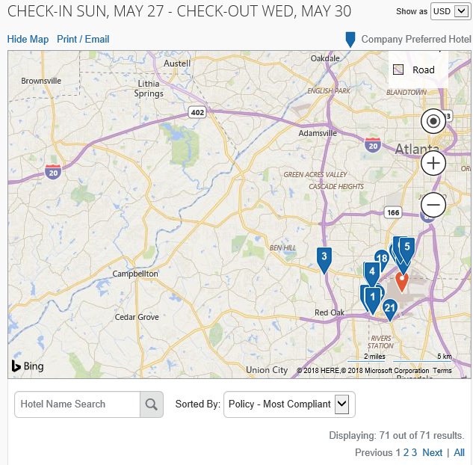
- Click any blue icon to see specific hotel information. Use your mouse to zoom, and move the map, as needed.
The red icon indicates your reference point, and the blue icon shows your company’s preferred hotels.

Step 4: Sort the search results (as needed)
- Below the map, use the Hotel Name Search and Sorted By fields to sort the results.

Step 5: Review the results
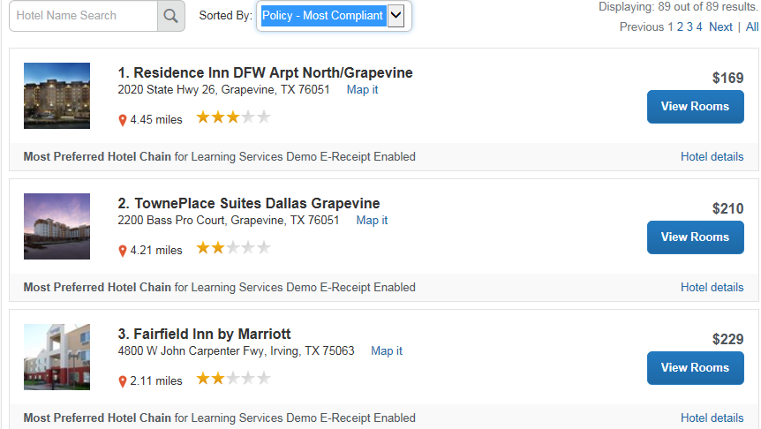
A picture as well as the name, address, rating stars, and price range appears.
- Click the picture to see more images.
- Click Hotel details to see contact information, street address, cancellation policy, and information about the facility.
- Click View Rooms to see:
- The available room options and rates
- Other amenities per room/rate
- Rules and cancellation policy

Step 6: Select the hotel room
- Click the Cost button next to the room that you want to reserve.
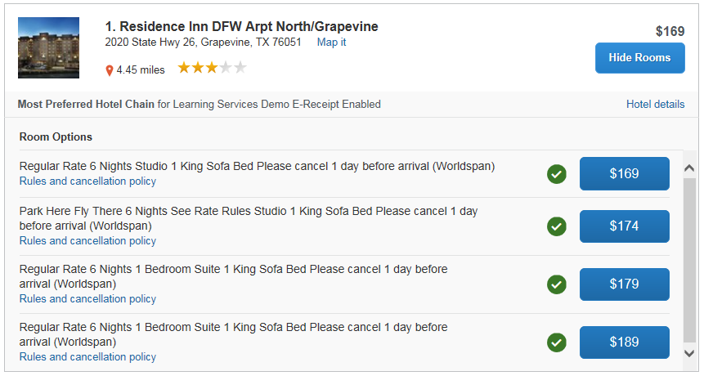
The Review and Reserve Hotel page appears. Navigate through the page and:
- Review or modify the room preferences.
- Verify or modify the guest and program information.
- Review the price summary.
- Select a method of payment, if available, as defined by your company's configuration.
- Review and accept the rate details and cancellation policy.
- Select the I agree to the hotel’s rate rules, restrictions, and cancellation policy check box.
- Click Reserve Hotel and Continue.
Your Travel Details page (itinerary) displays.

