**Federal Tax Elections in Workday**

Your federal tax elections will be maintained in Workday. Follow the steps below to update your federal tax elections and withholdings.

1. In Workday, select the **Pay** application on your Workday homepage.
2. Under the **Actions** menu, select **Withholding Elections**.

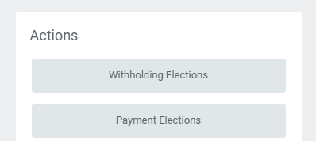

1. You will then be brought to the **Withholding Elections** page. Under the **Federal Elections** tab, click the **Update** button .
2. Fill out the following fields on the **Complete Federal Elections** page.
   1. **Company**: Defaults to **Emerson College**.
   2. **Effective Date**: Defaults to today’s date, but if necessary, change the date to when you want the update in your elections to take effect.

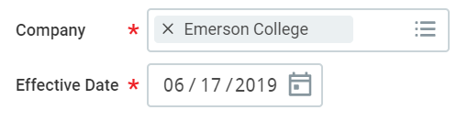

1. Click **OK** at the bottom of the page.
2. Fill out or choose the following on the **Federal Withholdings Certificate** page:
   1. 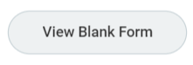**View Blank Form**: Allows you to view a blank Federal W-4 form to guide you through the following steps.
   2. 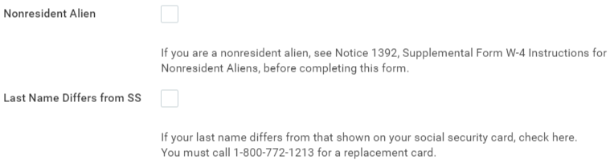**Nonresident Alien, Last Name Differs from SS (Social Security Number)**: Check the box(es) if they apply to you. NOTE: If NRA employees want to apply for any applicable Treaty Benefit – contact Payroll.
   3. **Marital Status**: Single, Married, or Married but withhold at higher Single rate.

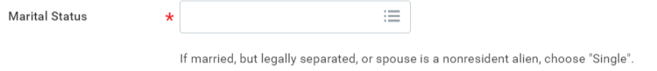

* 1. 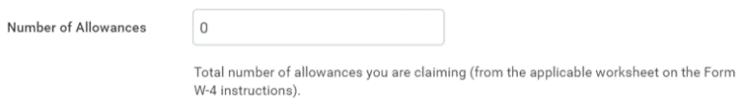**Number of Allowances**: Use the W-4 Personal Allowances Worksheet to determine your number of allowances.
  2. **Additional Amount**: If desired, enter an amount you want withheld from each paycheck.

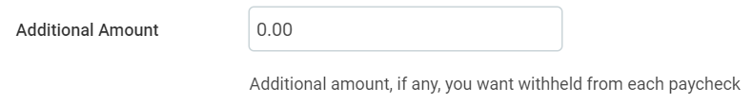

* 1. 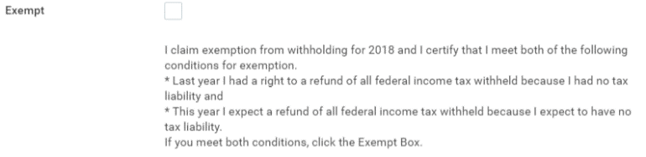**Exempt**: Check if qualify for exemption.
  2. Read the legal notice. Check I Agree, which will confirm you have read the legal notice and serve as your electronic signature.

1. Click **OK** at the bottom of the page.

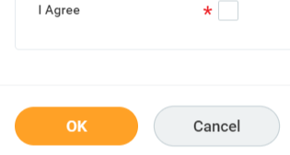

**What happens next?**

After submitting any changes to your tax elections, Emerson Payroll will review any changes you have made. You will be contacted if there are any questions about your submissions.