**Local Tax Elections in Workday**

Your local tax elections will be maintained in Workday. Follow the steps below to update your local tax elections and withholdings.

**Note**: Massachusetts and California do NOT have local taxes.

1. In Workday, select the **Pay** application on your Workday homepage.
2. Under the **Actions** menu, select **Withholding Elections**.

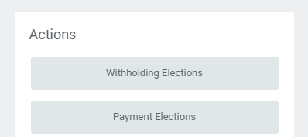

1. You will then be brought to the **Withholding Elections** page. Under the **Local Elections** tab, click the **Update** button .
2. Fill out the following fields on the **Complete State and Local Withholding Elections** page.
   1. **Company**: Defaults to **Emerson College**.
   2. **Effective Date**: Defaults to today’s date, but if necessary, change the date to when you want the update in your elections to take effect.
   3. **State**: Click into the field and select the state where your work address is.
   4. (For Connecticut, Hawaii, Massachusetts, Ohio, Wisconsin or North Carolina Residents) **Withholding Form Type**: A withholding form type will default into this field, but click into the field and change the form type if applicable.

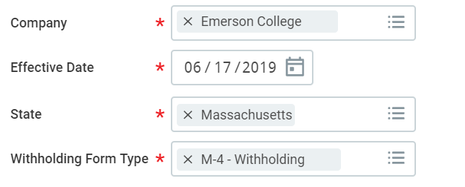

1. Click **OK** at the bottom of the page.
2. Fill out or choose the following on the **State and Local Withholdings Elections** page:
   1. 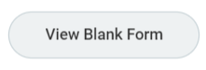**View Blank Form**: Click this button if you need to view a paper version of what you are filling out in Workday.
   2. Fill out the steps as indicated for the state you have selected. Some states will indicate different fields and steps for local taxes.
   3. Read the legal notice. Check **I Agree**, which will confirm you have read the legal notice and serve as your electronic signature.
3. Click **OK** at the bottom of the page.

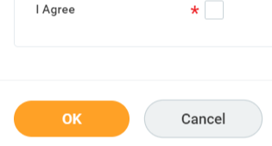

**What happens next?**

After submitting any changes to your tax elections, Emerson Payroll will review any changes you have made. You will be contacted if there are any questions about your submissions.