**Add or Update Payment Elections (Direct Deposit)**

Follow these steps to:

* Update your bank information or add an additional bank account for either your paycheck or expense reports
* Change your payment elections and quantities for your paycheck or expense reports

Prior to adding or updating your bank information, it may be helpful to have a check from your bank account(s) to assist as you add the information.

**Add a Bank Account**

1. 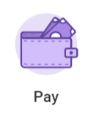Access the **Pay** application on your Workday homepage.
2. 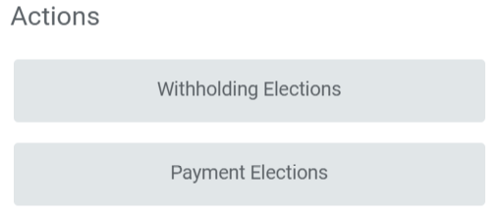Under Actions, select **Payment Elections**.
3. 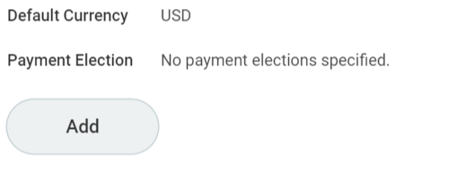If no bank information is available, or to add an additional account, click Add. To edit bank information skip to the “Edit Bank Information” section of this job aid.
4. **Account Information**: Fill out as noted below.

**NOTE**: Step A is an optional field and you should skip step D; Steps B, C, E and F are required.

* 1. **Account Nickname**: Useful if you have multiple accounts your pay is being deposited into.
  2. **Routing Transit Number**: Refer to the sample check on the Workday screen and your personal check to add this information.
  3. **Bank Name**: i.e. Santander, Bank of America.
  4. **Bank Identification Code (Optional)**: Skip this field, as this is used for non-US banks.
  5. **Account Type**: Select Checking or Savings.
  6. **Account Number**: Use the sample check on the Workday screen and your personal check to add this information.

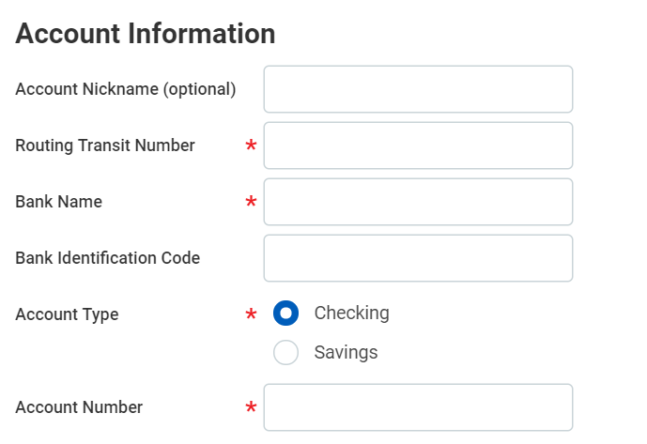

1. Click **OK** at the bottom of the screen when finished.

**Edit Bank Information**

1. Access the **Pay** application on your Workday homepage.
2. Under Actions, select **Payment Elections**.
3. 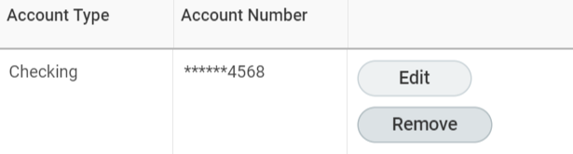To the right of the bank information you want to edit, select **Edit** to modify the information, or **Remove** to remove if the account is no longer needed.
4. If editing, update your bank information as listed in steps 3-5 under **Add a Bank Account** in this guide.
5. If removing, you must remove the account from your Payment Elections first. Then you can remove the account from the Account Information.

**Split Payment Elections (Paycheck)**

If you would like your paycheck to be deposited into more than one account, follow the steps below to do so. You can have up to 5 bank accounts in Workday.

**Note**: To split your payment elections, you must have at least 2 bank accounts added to your Workday profile.

1. Access the **Pay** application on your Workday homepage.
2. Under Actions, select **Payment Elections**
3. 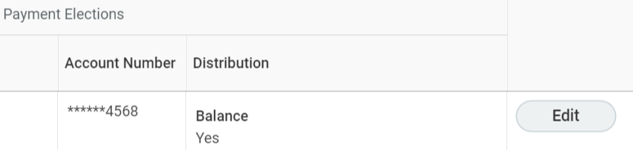Under the **Payment Elections** table, to the right of your **Regular Payroll** elections, click **Edit.**
4. To add an additional payment election, click the **+** sign. To remove, click the **Minus** sign and Click **OK**.

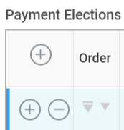

1. Select the information among the following fields:
   1. **Country**: Click into this field. Search for and select **United States of America**.
   2. 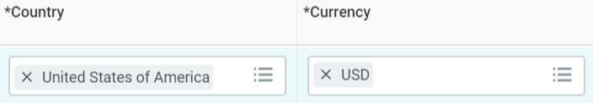**Currency**: Click into this field. Search for and select **USD**.
   3. **Payment Type**: Click into this field. Choose Direct Deposit.
   4. 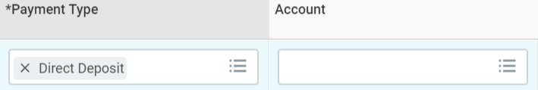**Account**: Click into this field. Select an account you have added for your pay to be deposited into.
2. **Balance / Amount / Percent**: Choose one of the following:
   1. **Percent**: Enter a percentage less than 100 of your net (post-tax and deductions) pay to be deposited into this bank account.
   2. **Amount**: Enter an amount less than your total net (post-tax and deductions) pay to be deposited into this bank account.
   3. 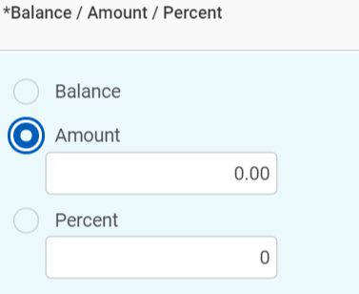**Balance**: The remaining amount of your net pay, minus amounts or percentages going to your other bank accounts listed in Workday. The account selected for Balance must be reordered to be the last account listed.
3. Click **OK** at the bottom of the page.

**Set up Expense Reimbursement election (Expense Rules)**

If you have not set up your expense reimbursement election, follow steps 1 -3 below to verify, then continue with steps 4 – 5 below.

If you have already set up your expense reimbursement election, then skip ahead to the **Edit Expense Reimbursement Election** section of this guide.

**Note**: Unlike for your paycheck, you are only allowed to have **one** account for expense reimbursements.

1. Access the **Pay** application on your Workday homepage.
2. Under Actions, select **Payment Elections**

3. If you have not set up your **Expense Rule** payment election, you will see a **Payment Elections Requiring Setup** table at the bottom of the page. If you do not see this table, then skip to the **Edit Expense Reimbursement Election** section of this job aid.

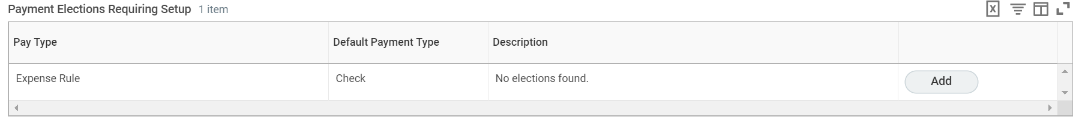

1. Click the **Add Button**, which will then prompt you to add an Expense Rule payment election (i.e. Your account for expense reimbursements). Follow the steps below to add the account.
   1. **Country**: Click into this field. Search for and select **United States of America**.
   2. **Currency**: Click into this field. Search for and select **USD**.
   3. **Payment Type**: Click into this field. Choose **Direct Deposit**.
   4. **Account**: Click into this field. Select an account you have added for your expense reimbursement to be deposited into.
   5. **Balance / Amount Percent**: Select the radio button next to **Balance**.
2. Click **OK** at the bottom of the page. You will then be returned to the Payment Elections page, where under the **Payment Elections** table, the **Expense Rule** pay type will appear with your account selection.

**Edit Expense Reimbursement Election (Expense Rules)**

Follow the steps below to edit your account for expense reimbursements in Workday.

**Note**: Unlike for your paycheck, you are only allowed to have **one** account for expense reimbursements.

1. Access the **Pay** application on your Workday homepage.
2. Under Actions, select **Payment Elections**
3. Under the **Payment Elections** table, to the right of your **Expense Rule** election, click **Edit.**
4. **Country**, **Currency**, **Payment Type** and **Balance** should remain the same.
5. Edit the **Account** field. Click into the field, then select an account you have added for your expense reimbursement that is different than the current account.
6. Click **OK** at the bottom of the page.